Solution Architecture

|  |  |
| --- | --- |
| Date | 1 October 2022 |
| Team ID | PNT2022TMID24431 |
| Project Name | Deep Learning Fundus Image Analysis for Early Detection of Diabetic Retinopathy. |

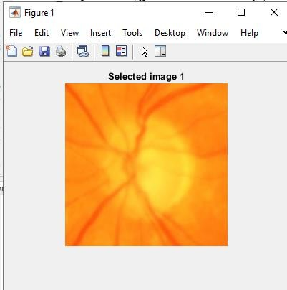

**Binary Image**

**Gabor magnitude**

**Gabor Phase**

**Note the Accuracy**

**Transform into watershed**

**Identify the layers of CNN**

**Training Progress**

**Testing Progress**

**Extract to Grayscale image**